ErrorLog Mastery Assignment
Error log
Stefan S
CSE 2120 Data Structures 1
(EvensAndOdds.java)
Describe the errors you’ve encountered while working on this assignment. What caused the error and how do you overcome the error?
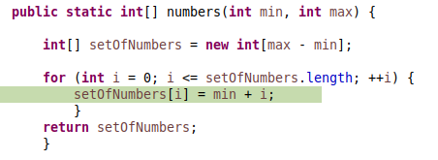
This code gave me an ArrayIndexOutOfBounds exception.
There are two problems here; First, when I declare setOfNumbers, the length is too short. I had to add a +1 in order to compensate for the index starting at 0.
Secondly, <= causes the array to go one index past it’s length and throw the exception. Using < was appropriate in this case.

This if statement appears to be using the index, rather than the value stored within the index, to calculate the result.
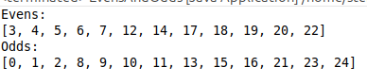
(It turns out, there were a number of compounding issues causing the index to be printed instead of the value! The main issue, was that once the if statement completed, I ran something like: evenNumbers.add(i)
Rather than the much more sensical:
evenNumbers.add(passedArray[i])

